**Lab 9**

**Profit by Date Line Chart**

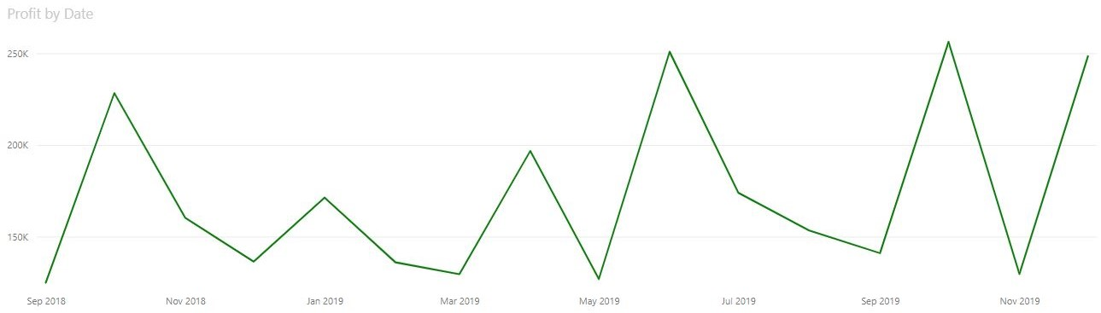

**Profit per Country World Map**

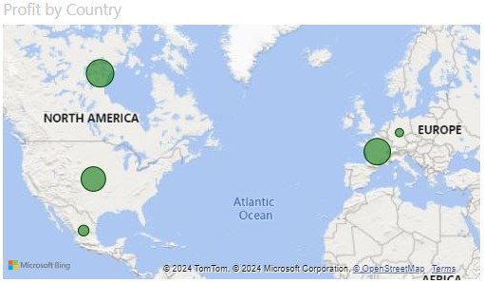

**Profit per Product Bar Chart**

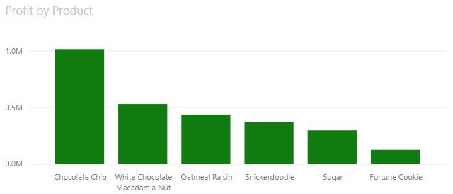

**Slicing the data for the United States**

